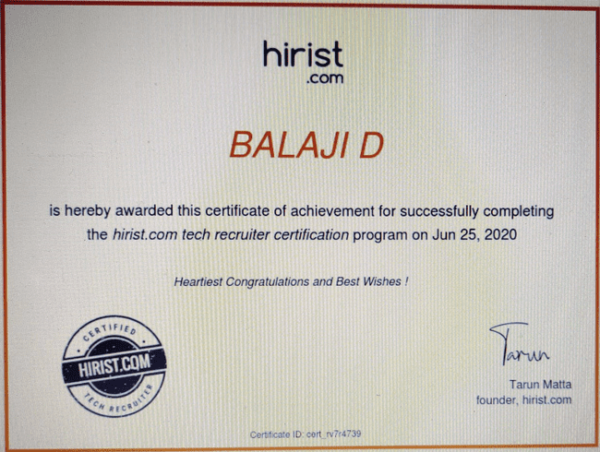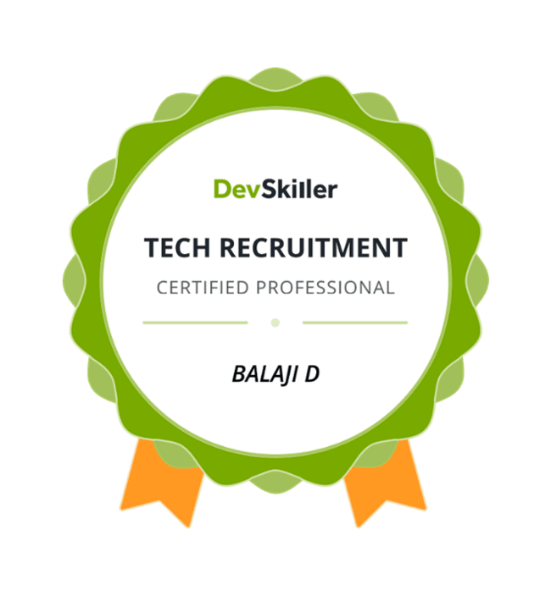

D.BALAJI
9110762251
balaji.usrm@gmail.com

Professional Summary

Forward-thinking Manager with comprehensive experience implementing new processes and managing and planning innovations. Bringing outstanding problem-solving and abilities paired with in-depth knowledge of policies and procedures. Polished in evaluating employee performance and overseeing key projects. Having 15 years of enriched and intense working in the IT industry in HR and Recruitment. Industry involving Global Resourcing & Recruiting - Offshore and Onsite Assignments.
- Involved in End-to-End Recruiting: Search – Source – qualify - Identify – deliver/ submission – Posting REQS on Job Portals Searching Internal Resume Database – Working with Qualified Vendors/Partners – Sending Bulk emails – Searching Database of x-employees (proven skills) in past– Searching on Job Boards– Emailing on Yahoo Groups/Google Groups
- Experience in working with Volume/Bulk hiring.
- Monitoring the performance of the recruitment team, ensuring compliance with pre-set quality parameters and meeting & exceed defined SLAs.
- Implement appropriate best recruitment and staffing practices in the organization.
- Responsible in hiring for Contract, Contract to Hire (C2H) and Permanent Positions.
- Directly responsible for hiring mid & senior level roles across all the Business units.
- Maintain & process corporate agreements & amendment.
- Joining formalities and Pre -Joining formalities
- Well versed with Online and offline Recruiting.
- Processed all recruitment invoices and general billing for HR department.
- Work closely with various stake holders located in the business to set priorities.
- Assist in development and execution of recruiting plans.
- Network and develop pools of external talent by researching and networking on job boards (Naukri, Monster etc.) and social networking sites.
- Evaluate applicants by discussing job requirements and applicant qualifications with hiring managers.
- Have experience in handling tax terms & Visas like W2, 1099, Green Card Holders, H1B, EAD and US Citizens.
- Strong in using Job-sites – DICE, Naukri, Jobs ahead, Monster etc.
- Have In-depth experience in Cold Call / Head Hunting IT professionals in Various Technical Skills
- Excellent short listing and negotiation skills and good team player.
- Experience using e-recruitment systems like Taleo, iCMSs, itap, Hire Craft, IQN, Fieldglass etc.
- Understanding the client recruitment needs and meeting their requirements with good response time.
- Experience in working with IT infrastructure domain skills, (Windows, Network, Ops Mgr., Program Managers, ITIL etc.)
- Generating reports on the individual performance of the employees.
- Maintaining Staffing Database.
- Exceptional focus and follow-through abilities, Innovative thinking, creative and meticulous.
- Excellent Communication and interpersonal dexterity while dealing with business end users and to discuss the client requirements.

Education:
- Master’s in Business Administration (MBA) with HR & Marketing in VIT University, Vellore.
- Bachelors in computers (B.Sc.) from S.V. University, Tirupathi.

Certification:
- Certified Tech Recruitment Professional – DevSkiller.
- Awarded NCC – “B” & “C” Certificate.

Project Done:
Project Title : “A Study on Stress Management in an organization”
Company Name : Biological E Ltd, Hyderabad.
Specialization Area : HR
Project Duration : 06 Months
Description:
Survey: As in the survey we conducted in an organization, a lot of employees working with stress. Which can be done by getting a questionnaire filled by the Employees?
Questionnaire was done by Descriptive research. Employees with less experience had more stress than the employees having a lot of experience. The format of the questioner and the wording and sequence of the questioner affects the validity of the responses.

Domains worked on:

- Banking / Investment banking
- Financial Services / IT Audit
- Information Technology
- Telecom
- Analytics
- Engineering and other few domains like Retail, Automobile partially

Skills:
- Stakeholder Management
- Account Management
- Client Engagement
- Delivery Management
- Vendor Management System (VMS)
- Lateral Hiring
- Leadership Hiring
- Negotiation
- End-End Recruitment
- IT & Non-IT Recruitment
- Human Resources Management
- Team Management
Technology Hired for IMS (Infrastructure Management System)
- Information Security Domain: Risk and Compliance, Audits, Antivirus Security / Firewalls.
- Network Domain: Routing, Switching, Security (checkpoint, RSA).
- Storage Domain: EMC Storage, IBM Storage, HP Storage, Hitachi.
- ITIL: Problem Management, Incident, Change, Service desk.
- Microsoft Technologies: Windows, Exchange, Lync.
- SMAC Expertise. (Social, Mobility, Analytics & Cloud) which includes DevOps, Bigdata, Hadoop, etc.

Training
- Undergone SAP HR Course ECC 5.0 at Methodex technologies at Hyderabad.

Partial List of client and preferred vendors worked with:

AT&T, Deloitte, HP, T-Mobile, Texas Capital Bank, Duetsche Bank, Toyota, SLK Software, BOA, Pfizer, CTS, Shell, I Gate, HCL, L&T, Verizon, Blue Cross/Blue Shield, GM, GE Medical Systems, HCL, First American Corp, TIMKEN, Mindtree, Net Cracker, PWC, Societe Generale, Philips, Tek Systems, CIBER, States farm, Liberty Mutual, Amex, Sony, Boeing, PSEG, NRG Energy, Symphony Teleca(Harman), Merck, NBCU, Owens Corning, Best Buy, BI Worldwide, Wipro, Accenture, KOCH, TCS, Big Info Labs, Si2 Chip Technologies Pvt Ltd, Indegene, Infinite Computer Solutions, Bharath innovation labs, XOXODAY, US Software Services Group, Invage Systems, Decision Minds, Capgemini, Moonraft Innovation Labs and IBM.
Work Experience

Protiviti
Manager Talent Solutions 10/2022 – 04/2024

Responsibilities:

- Handling a team of 5+ members.
- Handling both Non-IT & IT for internal & external hiring needs.
- Engage with stakeholders to understand business needs.
- Develop and sustain effective new business relationships with accounts/clients and independently handle staffing business.
- Monitoring the performance of the recruitment team, ensuring compliance with pre-set quality parameters and meeting & exceed defined SLAs.
- Post openings in job boards, social media, and in other appropriate venues.
- Research and recommend new sources for active and passive candidate recruiting.
- Responsible for hiring only Contract & C2H positions.
- Prioritizing requirements and ensuring that all prioritized requirements are worked upon and timely submissions are made.
- Involved in the weekly and monthly meetings and understanding the techniques to get the job done efficiently.
- Excellent problem-solving abilities with a strong technical background, good communication and interpersonal skills.
- Driving the team to achieve their targets.

Alchemy TechSol 05/2021 – 09/2022
Delivery Manager

Responsibilities:

- Handling a team of 10+ members.
- Responsible for daily full life cycle recruitment of both Information technology and information systems professionals for projects based and strategic staffing requirements for fortune 500 corporations.
- Monitoring the performance of the recruitment team, ensuring compliance with pre-set quality parameters and to meet & exceed defined SLAs.
- Develop and sustain effective new business relationships with accounts/clients and independently handle staffing business.
- Responsible for hiring Only Permanent Positions
- Measures and analyses key recruiting metrics for the purpose of managing recruiting effectiveness and educating our clients.
- Work closely with business in order to deeply understand team’s organization structure, responsibilities, strengths/weaknesses and key business drivers. Utilize this information to develop the most effective recruiting strategies.

Success Consulting Services. 08/2020 – 04/2021
TA Manager
Responsibilities:

- Involved in full-cycle Recruitment including Requirements understanding, identifying right candidates Initial screening, short listing, negotiating salary/rates and making offers.
- Involved in organizing the team of 5+ members.
- Sourcing candidates from all the various sources like job boards, employee referrals and more generating references from candidates.
- Responsible for hiring Permanent Positions
- Submission of the eligible resumes to the client

LanceSoft India Pvt Ltd. 01/2020 – 06/2020
Assistant Manager – Recruitment Client Services

Responsibilities:

- Responsible for daily full life cycle End – End recruitment.
- Involved in business development in getting new clients.
- Handling a team of 4 Members.
- Acting as a Individual Contributor (IC} Role as well.
- Engage with stakeholders to understand business needs.
- Develop and sustain effective new business relationships with accounts/clients and independently handle staffing business.
- Network and develop pools of external talent by researching and networking on job boards (Naukri, Monster etc.) and social networking sites.
- Evaluate applicants by discussing job requirements and applicant qualifications with hiring managers.

Manager Talent Acquisition 02/ 2017 – 01/2020
SunPlus Software Technologies Pvt Ltd., Bangalore.

Responsibilities:
- Handling a team of 6+ members.
- Responsible for daily full life cycle recruitment.
- Involving in business development in getting new clients.
- Develop and sustain effective new business relationships with accounts/clients and independently handle staffing business.
- Post openings in job boards, social media, and in other appropriate venues.
- Research and recommend new sources for active and passive candidate recruiting.
- Responsible for hiring only Permanent positions.
- Measures and analyses key recruiting metrics for the purpose of managing recruiting effectiveness and educating our clients.
- Consult with internal clients on overall recruiting strategy for both the short- and long-term needs of the business.

Practice Lead (Recruitment Manager) 07/ 2015 – 12/ 2016.
ALP Consulting Ltd., Bangalore.

Responsibilities:
- Managing a team size of 18+ Members.
- Responsible for daily full life cycle recruitment.
- Engage with stakeholders to understand business needs and Assist in development and execution of recruiting plans.
- Responsible for hiring Permanent and Fulltime positions.
- Network and develop pools of external talent by researching and networking on job boards (Naukri, Monster etc.) and social networking sites.
- Evaluate applicants by discussing job requirements and applicant qualifications with hiring managers.
- Work closely with various stake holders located in the business to set priorities.
- Directly responsible for hiring mid & senior level roles across all the Business units.
- Screening candidates to ensure their skills, experience and knowledge meet open positions.
- Submission of the eligible resumes to the client
- Joining formalities and Pre -Joining formalities
- Establish and maintain a good relationship with the employees and the clients.

Senior Executive –Client Services (Lead Recruiter) 01/2012 - 04/2015
Helios & Matheson It Ltd., Bangalore.

Responsibilities:
- Involved in full-cycle Recruitment including Requirements understanding, identifying right candidates Initial screening, short listing, negotiating salary/rates and making offers
- Involved in organizing the team of 5+ members.
- Sourcing candidates from all the various sources like job boards, employee referrals and more generating references from candidates.
- Responsible for account management, team management and delivery.
- Requirement Gathering, Sourcing Strategies, Delivery Plan and Execution
- Utilization of job boards like Dice.com, Monster.com, for finding the right candidates.
- Vendors contacts, User Groups, Candidates Pool and Database, Etc.
- Strong Experience on Banking, Healthcare, Pharmaceutical, Finance and Mortgage and IT infrastructure requirements.
- Worked with VMS (Vendor Management System) for client.
- Expertise in search techniques (Boolean Strings) in various search engines (GOOGLE, YAHOO).
- Screening candidates to ensure their skills, experience and knowledge meet open passions.
- Negotiated hourly rates with consultants according to employer profit margin for contract placements (C2C/1099/W2)
- Sourcing candidates from LINKED IN and other social networking sites.
- Screening resumes as per the requirements.
- Interviewed qualified consultants and assessed their skills (per client request), for Contract, Contract to hire (C2H), Full time (Permanent) placements across US.
- Involved in both Contract and Full-Time positions.
- Negotiate contract terms with consultants.
- Involved in the weekly and monthly meetings and understanding the techniques to get the job done efficiently.
- Excellent problem-solving abilities with a strong technical background, good communication and interpersonal skills.
- Driving the team to achieve their targets.
- Able to multi-task and work within deadlines.
- Coordinating with the team leader and Preparation of reports, records, maintenance and general MIS.
- Maintaining a strict SLA and TAT for fulfilling client requirements.

Recruitment Specialist /Lead 02/2008 - 12/2011
Priority Solutions, Bangalore.

Responsibilities:
- Responsible for daily full life cycle End – End recruitment.
- Collecting job requirements from the Sales team and posting the same to the leading job portals
- Source, screen and interview potential technical candidates for current and future positions
- Sourcing Candidates from social networking sites like LinkedIn and other sites as well.
- Utilization of job boards like Naukri.com, Monster.com, for finding the right candidates
- Screening candidates to ensure their skills, experience and knowledge meet open positions
- Negotiate contract terms with consultants.
- Submission of the eligible resumes to the client
- Joining formalities and Pre -Joining formalities
- Establish and maintain a good relationship with the employees and the clients.
- Arranging Client visit for technical interviews.
- Act as an interface between consultants & the organization

Bangalore D.Balaji.

